**CO2 distributor selection:**

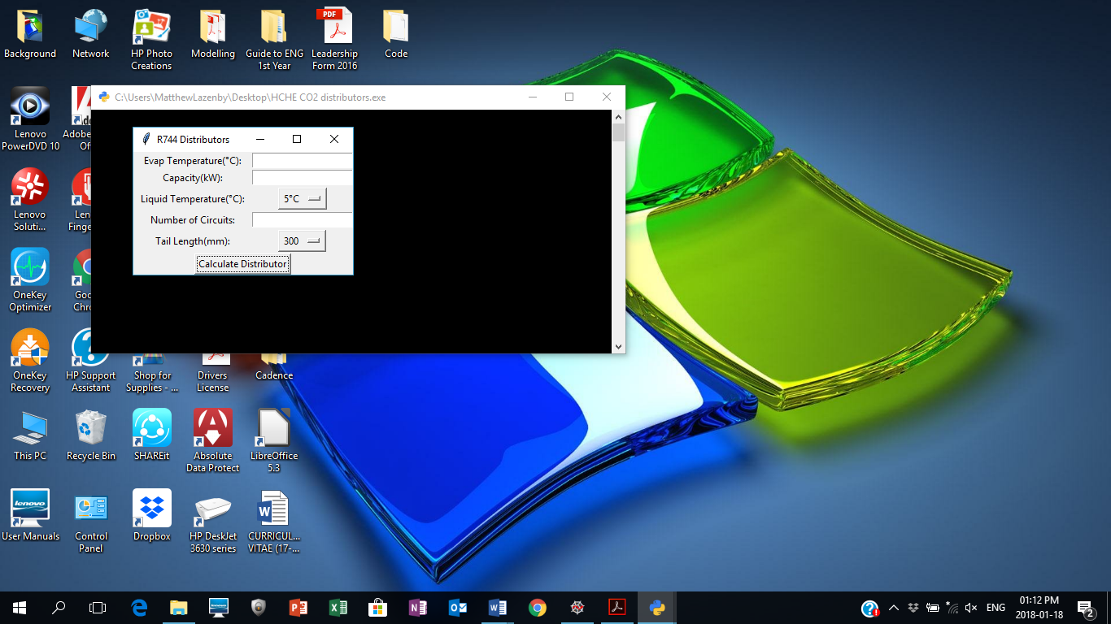**Using the .exe**The .exe application simply needs to be copied from user to user with any removable device, the .exe file to be copied is “HCHE CO2 distributors”. Once the .exe has simply been copied across, to run the application double click on the .exe application icon. Upon execution of the application a window may or may not pop-up where you will need to grant the application permission to run. A command prompt will then run and the Graphical User Interface(GUI) will appear on screen, this may take a while to load, do not kill the command prompt as this will end the execution, Figure 1 is the desired open application with the running command prompt in the background.

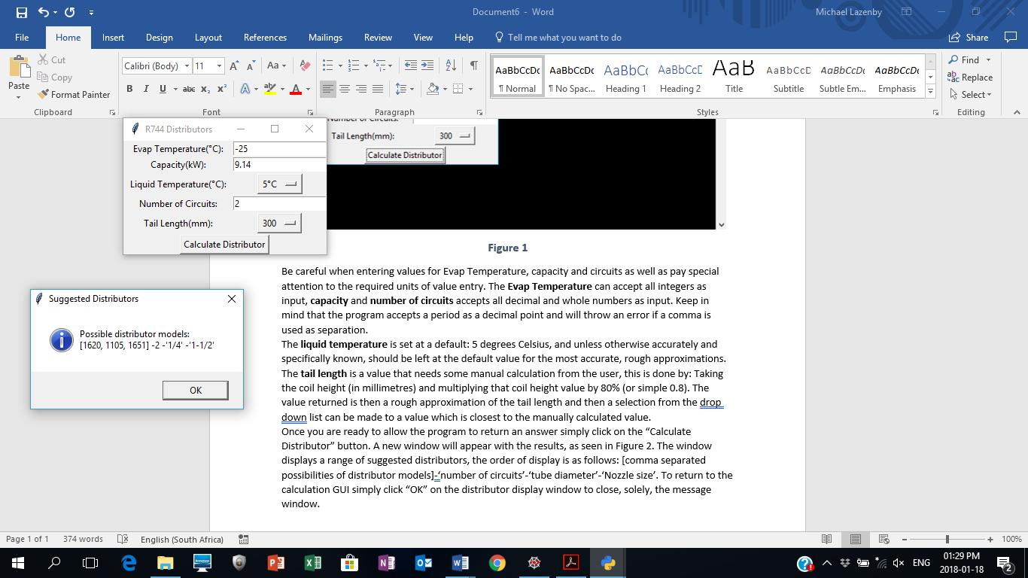Be careful when entering values for Evap Temperature, capacity and circuits as well as pay special attention to the required units of value entry. The **Evap Temperature** can accept all integers as input, **capacity** and **number of circuits** accepts all decimal and whole numbers as input. Keep in mind that the program accepts a period as a decimal point and will throw an error if a comma is used as separation.   
The **liquid temperature** is set at a default: 5 degrees Celsius, and unless otherwise accurately and specifically known, should be left at the default value for the most accurate, rough approximations. The **tail length** is a value that needs some manual calculation from the user, this is done by: Taking the coil height (in millimetres) and multiplying that coil height value by 80% (or simple 0.8). The value returned is then a rough approximation of the tail length and then a selection from the drop-down list can be made to a value which is closest to the manually calculated value.  
Once you are ready to allow the program to return an answer simply click on the “Calculate Distributor” button. A new window will appear with the results, as seen in Figure 2. The window displays a range of suggested distributors, the order of display is as follows: [comma separated possibilities of distributor models]-‘number of circuits’-‘tube diameter’-‘Nozzle size’. To return to the calculation GUI simply click “OK” on the distributor display window to close, solely, the message window.

**Figure 1**

**Figure 2**

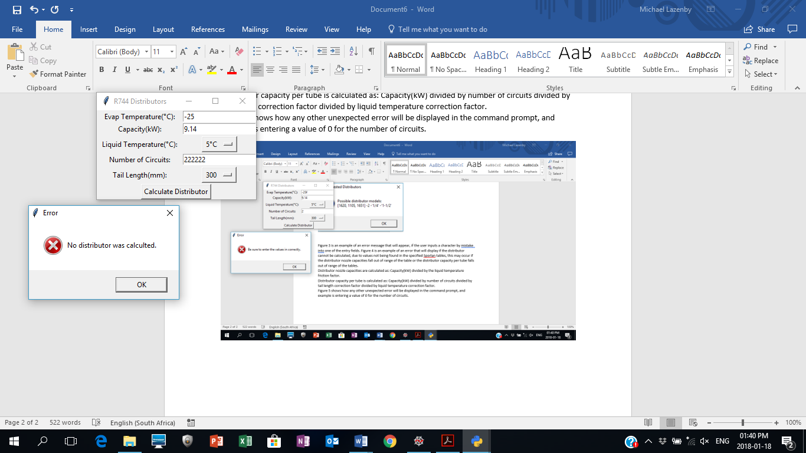Figure 3 is an example of an error message that will appear, if the user inputs a character by mistake into one of the entry fields. Figure 4 is an example of an error that will display if the distributor cannot be calculated, due to values not being found in the specified Sporlan tables, this may occur if the distributor nozzle capacities fall out of range of the table or the distributor capacity per tube falls out of range of the tables.  
Distributor nozzle capacities are calculated as: Capacity(kW) divided by the liquid temperature friction factor.  
Distributor capacity per tube is calculated as: Capacity(kW) divided by number of circuits divided by tail length correction factor divided by liquid temperature correction factor.  
Figure 5 shows how any other unexpected error will be displayed in the command prompt, and example is entering a value of 0 for the number of circuits.

**Figure 4**

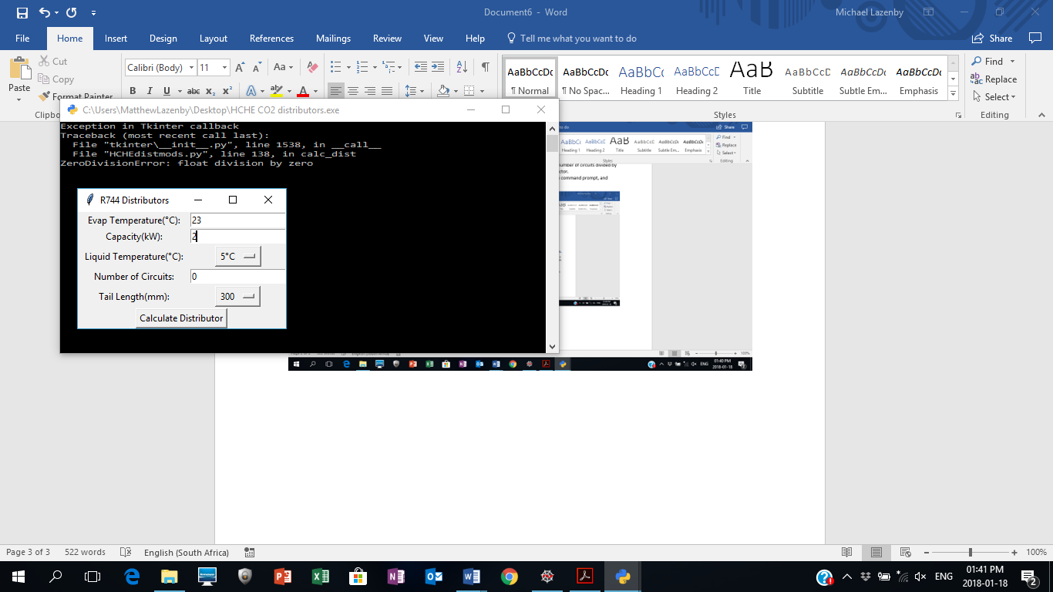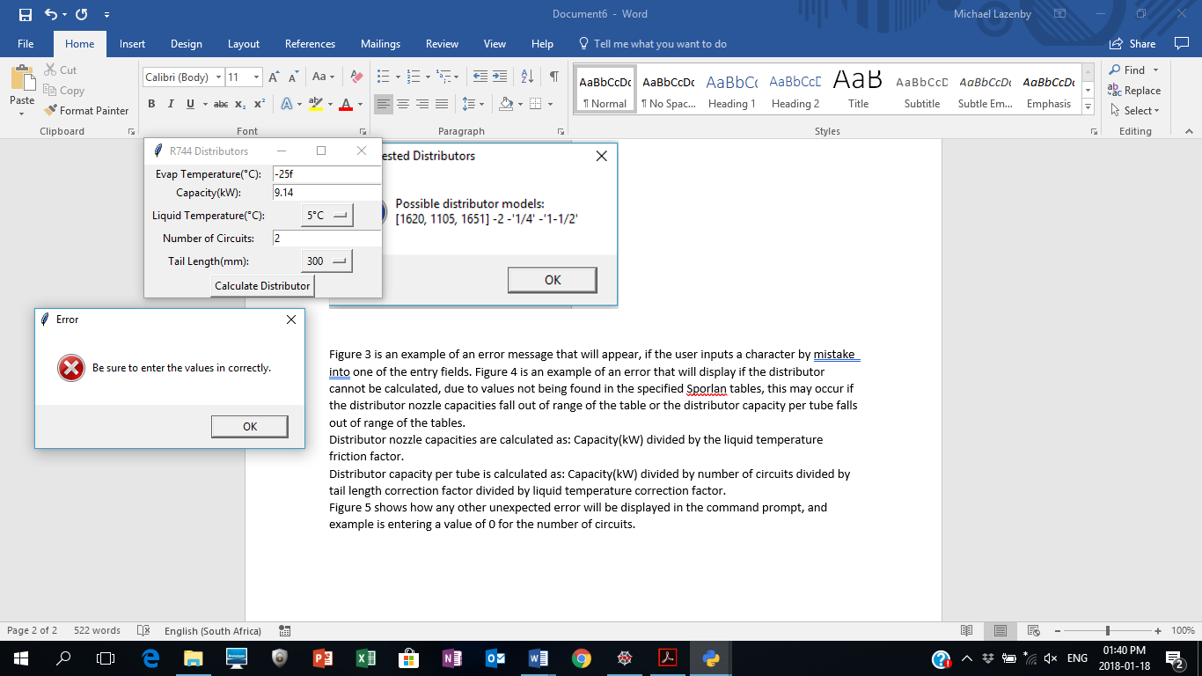To close the application simply exit the command prompt or exit the application itself.

**Figure 5**

**Figure 3**

**Accessing the program code**First Anaconda must be installed, to do this simply run the anaconda installer file and follow onscreen instructions, be sure to recognise and remember the path to which anaconda will install. Once installed simply go to the path directory of anaconda and in the address bar of the path type in spyder to open the programming platform. Another way to open spyder would be through the anaconda navigation application that automatically installs when installing anaconda. A new file can then be opened from spyder where the HCHEdistmods.py file can be opened. Some adjustments will need to be made to the code, as the code is built to run with the .exe file and not alone. Simply look through the code and everywhere, where the code calls the excel spread sheet called distributor model simply ensure that the excel spread sheet is in the same file path that the .py file is in, if the excel spread sheet appears in a folder which is in the same path as the .py file simply add the folder name followed by a forward slash before the excel file name that appears in the code(this should be numerous occasions), if not done and the excel spread sheet can’t be found, figure 6 displays the error that will appear.

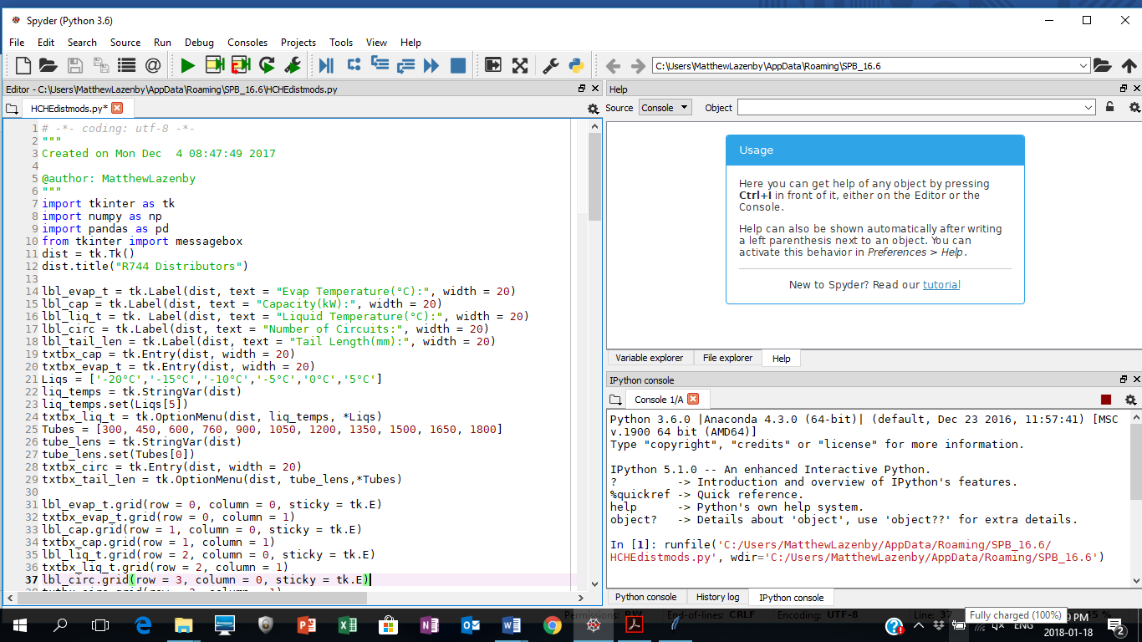

**Figure 6**